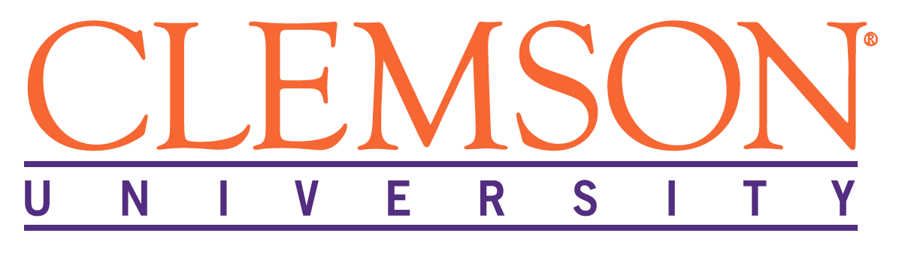 CURI Confined Space Entry
Program

Program Objective
Clemson University Restoration Institute (CURI) is committed to the safety and health of its employees. Therefore, employees are provided with confined space and permit required confined space training to be able to distinguish between the two. Employees are prohibited from entering Permit Required Confined Spaces.
Purpose and Scope
CURI has referenced the Clemson University plan to ensure that employees will not enter Permit Required Confined Spaces and have been properly trained to identify and protect against known hazards.
Permit Required Confined Space Program
A Permit Required Confined Space program is located on the Clemson University website and can be viewed here:
https://cufacilities.sites.clemson.edu/documents/safety/Confined%20Space%20Permit%20Required.pdf

